Golf
In golf certain clubs will drive a certain length. Prompt the user for the length of a hole, the number of clubs in the bag and the length each club will carry the ball, and then print out the least number of shots it takes to get to the hole or indicate that it is impossible to get to the hole.
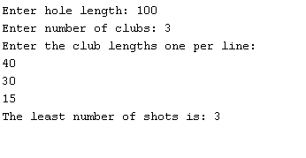
More challenging version: Indicate how many shots of each club were taken.

